American University of Beirut
Department of Electrical and Computer Engineering

EECE 490/690 - Introduction to Machine Learning

Project Report – Topic #9
Counter Speech Detection and Speaker Recognition

Submitted By:
Theana Mansour (ID: 202401365)
Talia Semaan (ID: 202400888)
Titia Saikali (ID: 202402636)
Maryam Abou Merhi (ID: 202404453)
Table of Contents
I. Submission Folder Overview 3
II. Project Overview 6
III. Research: ASR 6
1. Overview 6
2. How an ASR System works 7
3. Machine Learning Models for ASR: 7
4. Training, Evalutation and Datasets 8
5. Current Challenges and Trends in ASR 8
IV. Testing the effect of random sounds on microsoft teams speech detection 9
1. Instructions to run the code 9
2. Objective 9
3. Methodology 9
4. Observations 11
5. Conclusion 12
V. Full Pipeline Implementation 12
1. Pipeline Overview 12
2. Instructions to run the code: 13
3. Results and Evaluation (of the full pipeline) 14
a) WER to evaluate Speech Detection 14
b) Signal-to-Noise Ratio to evaluate distortion 15
c) Cosine similarity to evaluate Speaker Recognition 16
VI. References 17

- Submission Folder Overview
Our submission includes all source code, audio datasets, processed files, evaluation outputs, and project documentation. The folder is organized as follows:
- “python codes” folder: This folder includes all 3 python scripts we wrote:
- “randomnoise.py”: this python code was responsible for generating and playing the five synthetic sounds in real time to test how Microsoft Teams’ live transcription reacts to different acoustic disturbances. The full description is found in part “IV - Testing the effect of random sounds on microsoft teams speech detection”
- “testing_attacks phase 1”: this Python script was used only for our preliminary experimentation and does not represent our final system implementation. It generated a set of simple, classical audio manipulations (time-stretching, pitch-shifting, low-pass filtering, Gaussian noise, and combined distortions) to conduct our preliminary tests. The code is located in the “python codes” folder, and the resulting audio and Excel files are stored in the “testing_attacks phase 1” directory. Since these manipulations do not realistically disrupt live conversations, we later shifted to the Teams-based synthetic sound patterns for the real evaluation.
- “testing_attacks phase 2”: this Python script contains our full and final implementation of the evaluation pipeline. It preprocesses the dataset, applies the five Teams-inspired sound attacks directly to the waveform, and computes all quantitative metrics including WER, SNR, and speaker-embedding cosine similarity. All generated manipulated audio files and the corresponding results (CSV files) are located in the “testing_attacks phase 2” directory. The full description is found in part “V – Full Pipeline Implementation”.
- “small_data” folder: The small_data folder contains the original speech recordings used as the input dataset for all experiments. Each file is an unedited MP3 clip that is referenced in the ground-truth transcript CSV (small_data.csv). This folder serves as the baseline source from which all preprocessing, manipulations, and evaluations in Phases 1 and 2 were generated.
- “teams testing (video + transcript)” folder: This folder contains the screen recording and transcript of our Microsoft Teams experiment, explained in part “IV - Testing the effect of random sounds on microsoft teams speech detection”.
- “Teams Recording - Transcript.docx”: This Word document includes the full transcript produced by Teams during the test.
- “Teams Recording.mp4”: This is the video recording of our Teams experiment.
- “testing_attacks phase 1” folder: This folder contains all the resulting audio and Excel files from our “testing_attacks phase 1.py” script. This work represents our preliminary experimentation and is not our final work.
- “indiv_attacked_processed_small_data” folder: This folder contains the individually manipulated audio files generated during Phase 1. Each subfolder corresponds to one classical audio attack, and each subfolder contains the 50 processed WAV files, one for every recording in small_data. The subfolders are:
- “lowpass” subfolder: this contains the 50 audio files filtered with a 6th-order low-pass filter at 2.5 kHz, keeping only lower frequencies..
- “noise” subfolder: this contains the 50 audio files corrupted with additive Gaussian noise at 10 dB SNR, making the speech noticeably noisier..
- “pitch_shift” subfolder: this contains the 50 audio files with their pitch shifted by +4 semitones.
- “time_stretch_faster” subfolder: this contains the 50 audio files time-stretched with rate 1.2, making the audio play faster and shorter
- “time_stretch_slower” subfolder: this contains the 50 audio files time-stretched with rate 0.8, making the audio play slower.
- “processed_small_data” folder: This folder contains the standardized clean WAV versions of all original MP3 recordings located in the small_data folder. Each file has been resampled to 16 kHz, converted to mono, and normalized to a uniform amplitude range using the preprocessing pipeline. These files serve as the baseline “clean” audio used for generating both the individual and combined attacks in Phase 1.
- “mult_attacked_processed_small_data” folder: This folder contains one subfolder titled “pitch+time+noise”. The subfolder holds all 50 audio files where each recording was first pitch-shifted by +4 semitones, then time-stretched slower (rate 0.8), and finally corrupted with Gaussian noise at 10 dB SNR.
- “indiv_attack_metrics.csv” file: Excel file generated automatically when we run the python code. It contains the WER, SNR, and L2-norm results for each individual classical manipulation. Each row corresponds to one audio file attacked with a single distortion.
- “indiv_attack_speaker_recognition.csv” file: Excel file generated automatically when we run the python code. It contains the cosine similarity scores between the clean and individually manipulated files, showing how each single distortion affected speaker recognition.
- “mult_attack_metrics.csv” file: Excel file generated automatically when we run the python code. It contains WER, SNR, and L2-norm results for the combined attack (pitch + time-stretch + noise). Each row represents one audio file after all three distortions were applied together.
- “mult_attack_speaker_recognition.csv” file: Excel file generated automatically when we run the python code. It includes cosine similarity scores for the combined attack, measuring how the multi-attack setup impacted speaker-identity preservation compared to the clean audio.
- “testing_attacks phase 2” folder: This is our actual evaluation pipeline, where the Teams-inspired attacks were applied directly to the waveform, and all WER, SNR, and speaker-recognition metrics were computed, as described in part “V – Full Pipeline Implementation”.
- “indiv_attacked_processed_small_data” folder: This folder contains the individually manipulated audio files generated during Phase 2. Each subfolder corresponds to one Teams-style sound attack, and each subfolder contains the 50 processed WAV files (one for every recording in small_data). The subfolders are:
- “chirp” subfolder: this contains the 50 audio files mixed with a frequency-sweeping chirp (200–600 Hz up to 1000–3000 Hz).
- “glitch” subfolder: this contains the 50 audio files mixed with intermittent bursts of glitch noise, appearing every 5000 samples.
- “overlap_sine_wave” subfolder: this contains the 50 audio files mixed with three overlapping sine waves at random frequencies (200–2000 Hz).
- “single_sine_wave” subfolder: this contains the 50 audio files mixed with a single sine tone at a random frequency between 200–1000 Hz.
- “white_noise” subfolder: this contains the 50 audio files corrupted with broadband uniform white noise.
- “processed_small_data” folder: This folder contains the standardized clean WAV versions of all original MP3 recordings located in the small_data folder. Each file has been resampled to 16 kHz, converted to mono, and normalized to a uniform amplitude range using the preprocessing pipeline. These files serve as the baseline “clean” audio used for generating both the individual and combined attacks in Phase 2.
- “indiv_attack_metrics.csv” file: Excel file generated automatically when we run the Phase 2 python code. It contains the WER and SNR results for each Teams-style attack (white noise, single sine wave, chirp, glitch, overlapping sine waves). Each row corresponds to one audio file attacked with a single Teams-based manipulation.
- “indiv_attack_speaker_recognition.csv” file: Excel file generated automatically when we run the Phase 2 python code. It includes the cosine similarity scores between the clean and individually manipulated files, showing how each Teams-style attack affected speaker recognition.
- “indiv_attack_metrics - Organized.csv” file: This is a manually organized version of “indiv_attack_metrics.csv”, formatted for readability and used to compute the grouped statistics presented in the Results section.
- “indiv_attack_speaker_recognition - Organized.csv” file: This is a manually organized version of “indiv_attack_speaker_recognition.csv”, formatted for readability and used to compute the grouped statistics presented in the Results section.
- “EECE 490 - Project Presentation.pptx” file: This PowerPoint file contains the final presentation presented in class. It summarizes our project, including the research background, Teams testing results, full pipeline implementation, evaluation metrics, and sample audio comparisons.
- “EECE 490 - Project Proposal.docx” file: This file contains our original project proposal submitted at the beginning of the semester. It outlines the problem definition, objectives, planned methodology, technical stack, evaluation criteria, and research motivation.
- “EECE 490 - Project Report”: This is the full written report of our project. It includes all research content, the Teams experiment, the complete implementation pipeline, evaluation results, folder overview, and references. It serves as the official final documentation of Project #9. (This is the document you are currently reading.)

- Project Overview
Nowadays, speech and speaker recognition technologies have become integral to everyday life, powering applications such as virtual assistants, automated transcription services, biometric authentication, and smart surveillance systems.
What is Speech Recognition? Speech recognition is the technology that allows computers and other devices to recognize and analyze human speech. It entails converting spoken words into texts or commands that a computer can comprehend and carry out. The system “captures audio input, analyzes the sounds and matches them to words or phrases in its database to produce an accurate interpretation” [1]. Common real-life usages of this technology include: voice search or assistants, speech-to-text, voice commands to smart home devices, voice biometrics for security, and more [2].
What is Speaker Recognition? Speaker recognition is “a biometric modality that uses an individual’s voice for recognition purposes” [3]. It differs from speech recognition (which only focuses on focuses on language content) as it analyzes the unique vocal features such as “the physical structure of an individual’s vocal tract and the behavioral characteristics of the individual” [3]. Speaker recognition systems work by examining the frequency characteristics of a person’s speech and comparing features such as signal quality, duration, intensity patterns, and pitch to identify the speaker [3].
Both technologies rely on analyzing different aspects of audio signals (content or identity) to produce accurate results. However, this raises privacy concerns as conversations can be automatically transcribed or speakers identified without consent.

- Research: ASR

Overview
Automatic Speech Recognition (ASR) refers to the task of converting spoken language into written text using computer systems. It is now embedded in many everyday technologies such as virtual assistants (e.g., Siri, Google Assistant), dictation software, automatic subtitles on video platforms, and call-center transcription tools.
Modern ASR is considered a core area within speech and language technology because it enables more natural human-computer interaction and supports important applications in accessibility, education, healthcare, and customer service.

How an ASR System works
2.1 Audio and preprocessing
First, a microphone records the speech and converts it into a digital signal (a waveform). Before recognition, the system often cleans the signal: it may remove background noise, trim long silences, and normalize the volume.
2.2 Feature extraction
Working on raw audio is difficult, so the system turns the signal into features that are easier to use. Common features are Mel filterbanks and MFCCs, which describe how the energy of the sound is spread across different frequencies in short time windows.
2.3 Acoustic / encoder model
These features go into a model that tries to understand which sounds or symbols are being spoken. In older systems, this was a statistical model (HMM-GMM). In newer systems, it is usually a deep neural network (for example an LSTM, Transformer, or Conformer) that outputs probabilities for characters, phonemes, or subword units at each time step.
2.4 Language model and decoding
Speech can be ambiguous, so the system uses a language model to choose the most likely word sequence. For example, it should prefer “recognize speech” over “wreck a nice beach”. Traditional systems used n-gram language models, while modern ones often use neural language models. A decoding algorithm combines the acoustic information and the language model to produce the final text.

Machine Learning Models for ASR:
  - Traditional hybrid systems (GMM-HMM and DNN-HMM)
For many years, ASR systems were built as hybrid models. They separated the problem into:
- an acoustic model (linking audio features to phonetic units), usually based on Hidden Markov Models (HMMs) with Gaussian Mixture Models (GMMs), and later deep neural networks (DNN-HMM), and
- a language model that scores how likely different word sequences are.
The system looks for the word sequence W that maximizes P(W∣X) , which is approximated as $P\left(W | X\right)∝P\left(X | W\right)P(W)$, where X is the sequence of acoustic features, P(X∣W) comes from the acoustic model, and P(W) from the language model.
Replacing GMMs with deep neural networks (DNN-HMM) gave large improvements in accuracy and was a major step forward before end-to-end models became popular.
3.2 End-to-end ASR
More recent research focuses on end-to-end models that learn to map audio features directly to text in one neural network, instead of using many separate components. Three main types are often mentioned:
- CTC models: Connectionist Temporal Classification (CTC) allows a network to learn from input-output pairs without knowing the exact alignment between frames and labels. The model outputs a distribution over characters (plus a “blank” symbol) at each time step, and the CTC loss sums over all valid alignments. CTC models are simple and good for streaming, but they often need an external language model during decoding.
- Attention-based encoder/decoder (Listen, Attend, Spell): In attention models such as Listen, Attend and Spell (LAS), an encoder network processes the whole audio sequence into high-level representations, and a decoder generates output tokens one by one while attending to relevant parts of the encoder output. This approach combines acoustic and language modeling in a single network and can capture long-range context, often giving very good accuracy on large datasets.
- Transformer and Conformer Models: Recently, Transformer and Conformer models have become state of the art. The Conformer adds convolution layers to the Transformer to better model local patterns (such as phonemes) together with global context. Conformer-based ASR, often trained with a combination of CTC and attention losses, achieves very low Word Error Rates on benchmarks such as LibriSpeech and is widely used in modern systems.
- Training, Evalutation and Datasets
Deep ASR models usually require large amounts of audio with transcripts. To reduce this need, self-supervised models (for example wav2vec 2.0 or Whisper-style systems) first learn from huge amounts of unlabelled audio, then are fine-tuned on smaller labeled sets.
The most common evaluation metric is Word Error Rate (WER): $$WER= \frac{Substitutions+Insertions+Deletions}{Number of Words Spoken}$$
Lower WER means better performance. For some languages or character-based systems, Character Error Rate (CER) is also used.
Standard datasets include LibriSpeech, Switchboard, CHiME (noisy speech), and multilingual resources like Common Voice, which allow fair comparison of different models.
- Current Challenges and Trends in ASR
Even though ASR is much better than before, there are still important challenges:
- Noise and real-world conditions: accuracy drops in noisy places, with echo, or when multiple people speak at once.
- Accents and low-resource languages: performance is usually best on standard accents and well-studied languages. Dialects and under-represented languages still need more data and better adaptation methods.
- Efficiency and latency: real-time apps on phones and embedded devices need models that are both accurate and fast, so research looks at smaller and more efficient architectures.
- Fairness and privacy: large ASR systems raise concerns about user data and about possible bias in performance across different groups of speakers.

- Testing the effect of random sounds on microsoft teams speech detection

Instructions to run the code
To run the “randomnoise.py” script, we simply require downloading the library: sounddevice using: pip install sounddevice.

Objective
The goal of this section was to generate random sounds and investigate how these sounds affect speech detection and transcription in Microsoft Teams.

Methodology
- Using Python libraries like numpy and sounddevice, five types of sounds were generated:
- White noise: random noise with values between -1 and 1
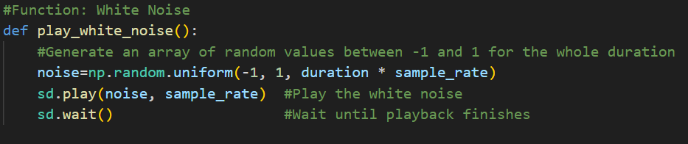
- Sine wave: a tone of random frequency between 200Hz and 1000Hz
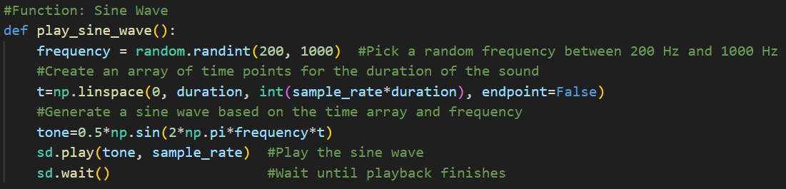
- Chirp: a tone that goes from a random starting frequency (200-600Hz) to a random ending frequency (1000-3000Hz) over the duration of the sound
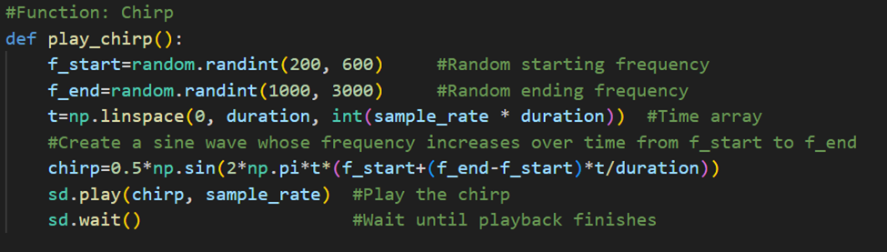
- Glitch Noise: short bursts of random noise appearing at intervals to simulate erratic signals
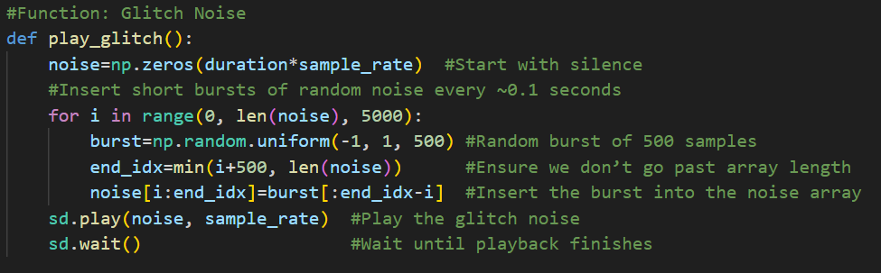
- Overlapping Sine Waves: Sum of multiple sine waves at random frequencies to create complex harmonic sounds.
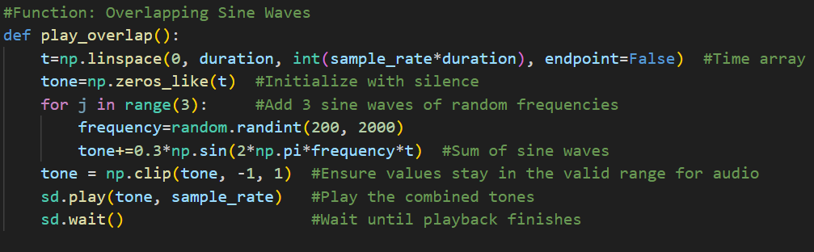
- In addition to sounds, we also tested two human speech recordings played at the same time, overlapping on top of each other.
- Each sound was generated for a duration of 10 seconds and played through the computer speakers using sounddevice
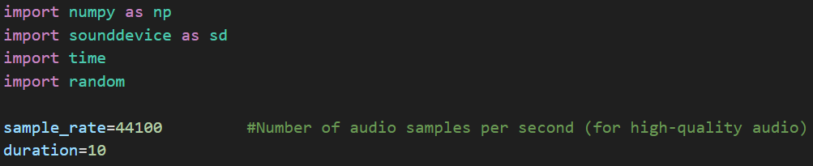
- The program randomly selected five sounds from the five options and played them consecutively, with a short pause in between.
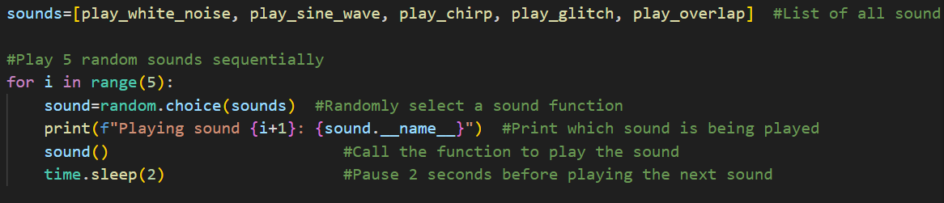
(terminal output example)
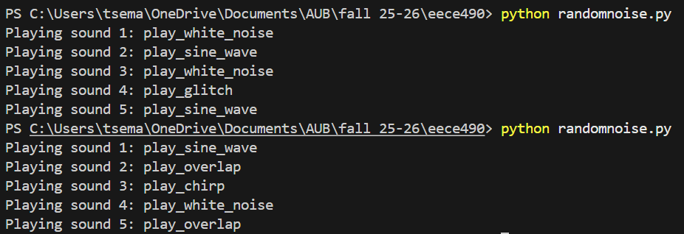
- While the sounds were playing, Microsoft Teams transcription was active. We observed whether Teams could still detect speech or whether the sounds interfered with detection.

Observations
- When white noise played, the transcription stopped detecting speech. Because white noise contains a wide frequency distribution, it masks human speech frequencies and overwhelms Teams’ detection system.
- When high-frequency sine waves were played, it often caused transcription to freeze or stop, especially when the frequency was above the typical speech range.
- We did not detect any abnormalities with chirp sounds or glitch noise, but that could be due to their volume being low
- Regular sine waves at lower frequencies had a slightly smaller effect but still sometimes disrupted transcription depending on amplitude and proximity to the microphone.
- Overlapping sine waves caused Teams to detect no speech. The harmonic mixture created a sound that completely masked human speech frequencies.
- Microsoft Teams consistently failed to separate the two overlapping speech audios. In most cases, the transcription either stopped completely, captured only one of the voices intermittently, or produced nonsensical text that was often cut off mid-sentence.

Conclusion
This experiment shows that Microsoft Teams transcription is highly sensitive to various disturbances like white noise, high-frequency tones, overlapping sine waves, and multiple speakers talking at once. These conditions often caused the transcription to stop, produce incorrect text, or ignore speech entirely. The overlapping-speech test also confirmed that Teams cannot separate voices and is designed for a single clear speaker. Overall, the results highlight the limitations of real-time transcription systems when exposed to synthetic noise or competing voices.

- Full Pipeline Implementation

Pipeline Overview
Before implementing our main evaluation system, we first tested a set of classical audio manipulations (time-stretching, pitch shifting, low-pass filtering, additive Gaussian noise, and combined perturbations). This code is found in the folder “python codes” under “testing_attacks phase 1.py” and the corresponding audio files and excel files are found in the “testing_attacks phase 1” folder. These attacks were applied to the original dataset to observe how traditional signal-processing distortions affect transcription accuracy and speaker identity. Although this preliminary phase provided useful insights, it remained limited in practical relevance. Techniques like pitch shifting or time stretching do not represent realistic ways to mask or disrupt a live conversation in real-world scenarios. For that reason, we shifted toward a more realistic and environment-based evaluation using the synthetic sound patterns we had tested on Microsoft Teams, which were proven to disrupt speech detection under real conditions.
Both phases 1 and 2 were tested using the 50 audio files located in the “small_data” folder. Those files were extracted from the Mozilla Common Voice dataset (Kaggle link: https://www.kaggle.com/datasets/mozillaorg/common-voice ).
After observing that Microsoft Teams malfunctioned under synthetic sound patterns (white noise, sine tones, chirps, glitch bursts, and overlapping sine waves), we implemented a second and more extensive evaluation pipeline. The goal of this phase was to apply these same sound patterns as controlled offline attacks to a large portion of our dataset, allowing us to compute accurate quantitative metrics: WER, SNR, and speaker-similarity degradation.
Our entire system was implemented in one python script called “testing_attacks_phase 2” that can be found in our zip file.
The script follows this main structure:
- We obviously started by loading all necessary modules and defining our files directories.
- We then loaded the two used models: whisper (which was used for speech detection testing) and ECAPA-TDNN embeddings from SpeechBrain (which was used in the speaker recognition testing).
- To correctly evaluate the manipulation impact, we first extracted the true reference transcripts from a CSV file (small_data.csv). The function correct_transcript() creates a dictionary mapping each filename to its corresponding clean transcript.
- We then loaded the original audio files (.mp3) from the dataset and standardized them to a unified format. The preprocessing pipeline resamples all audio to 16 kHz, uses mono conversion, normalizes them and saves the cleaned output as .wav files in the folder “processed_small_data”. These steps were implemented in the functions: get_all_audio_files(), load_audio(), preprocess_audio() and clean_files().
- We implemented five distinct manipulation techniques that correspond to common adversarial strategies:
  - White Noise (attack_white_noise()): uniform noise between -1 and 1
  - Single Sine Wave (attack_sine_wave()): one pure tone, random 200-1000 Hz
  - Chirp (attack_chirp()): a frequency sweep starting 200-600 Hz → ending 1000-3000 Hz
  - Glitch Noise (attack_glitch()): short bursts of random samples every 5000 samples
  - Overlapping Sine Waves (attack_overlap_sine()): three simultaneous random tones (200-2000 Hz)
Each attack strictly replicates the real-time behavior of the play_white_noise(), play_sine_wave(), play_chirp(), play_glitch(), and play_overlap() functions used previously for Teams testing, but applied directly to the waveform instead of being played through speakers.
- We tested each attack individually using the function apply_indiv_attacks(). This function: loads each clean file, then applies all five attacks (each on a new attacked file), saves the manipulated audios, computes evaluation metrics (word error rate WER and signal-to-noise ratio SNR) and finally logs everything into an excel file called indiv_attack_metrics.csv. The generated corrupted audio files were saved in the folder “indiv_attacked_processed_small_data”
- Inside the apply_indiv_attacks() functions, we used Whisper (tiny model) to transcribe the clean and manipulated audio files. For each file, we used the resulting texts to calculate WER of the true vs clean audio transcripts, WER of the true vs manipulated transcripts and WER of the clean vs manipulated transcripts, using jiwer library.
- Once all manipulated audio files were created, we tested for speaker recognition. We used the pretrained ECAPA-TDNN speaker model from SpeechBrain to create a function that gets the embeddings of a file called speaker_embedding(). We then created a function to calculate the cosine similarity of the clean and manipulated files. An evaluation functions handled this part: speaker_recognition_indiv(). The corresponding results were saved in a new excel file indiv_attack_speaker_recognition.csv.

- Instructions to run the code:
To reproduce our results and regenerate all Phase 2 outputs, the code must be executed using the same directory structure that we used during development. The script “testing_attacks phase 2.py” must remain inside the “python codes” folder, while the “small_data” folder (containing the original mp3 files and the file “small_data.csv”) must stay in the project root. Before running the script, all previously generated folders inside “testing_attacks phase 2” should be deleted, since the script automatically recreates “processed_small_data”, “indiv_attacked_processed_small_data”, and all other output subfolders.
If you prefer to keep our original output files, we can simply create a new empty folder inside the main “EECE 490 - PROJECT #9 - Theana Mansour, Talia Semaan, Titia Saikali, Maryam Abu Merhi” directory and change the line:
to point to the new folder name. The script will automatically generate all results in that new directory without touching our existing files.
testing_phase2_dir=project_root/"testing_attacks phase 2"
- Create the virtual environment: Open a Python terminal in the project root folder and run:
python -m venv venv
- Activate the virtual environment:
venv\Scripts\activate
- Install the needed modules and models:
pip install torch torchaudio numpy pandas librosa soundfile scipy openai-whisper jiwer speechbrain
Testing the full dataset (all 50 audio files in small_data) takes approximately 30 minutes. If a shorter test is preferred, the number of processed files can be reduced by editing the function get_all_audio_files() and adding a line such as audio_files = audio_files[:5], which will limit the pipeline to the first five audio files only.

- Results and Evaluation (of the full pipeline)
- WER to evaluate Speech Detection
To evaluate the impact of each manipulation technique on speech recognition, we computed the Word Error Rate (WER) between each manipulated transcript and the corresponding clean transcript. After exporting all results from our Python script into the CSV file indiv_attack_metrics.csv, we used Excel formulas to efficiently summarize the number of samples that fall into different WER thresholds for each attack.
We got the following distribution as seen in table 1:
WER Statistics
wer attack vs clean | TOTAL | white_noise | single_sine_wave | chirp | glitch | overlap_sine_wave
>=1 | 75 | 50 | 4 | 3 | 3 | 15
>=0.8 | 9 | 0 | 2 | 0 | 2 | 5
>=0.6 | 23 | 0 | 3 | 8 | 4 | 8
>=0.4 | 26 | 0 | 3 | 7 | 7 | 9
>0 | 63 | 0 | 19 | 15 | 20 | 9
0 | 54 | 0 | 19 | 17 | 14 | 4
TOTAL | 250 | (50 recordings + 5 attacks each)
Table 1. WER Statistics for Individual Attacks
Based on the WER distribution summarized in Table 1, we observe clear differences in how each Teams-style sound attack disrupts Whisper’s transcription accuracy. White noise was by far the most damaging: it produced 50 samples with WER>=1, meaning Whisper completely failed to transcribe every file when white noise was added. This result aligns with our observations during the Microsoft Teams experiment, where broadband noise overwhelmed the model and caused speech detection to collapse entirely.
The overlapping sine-wave attack was the second most harmful, generating 15 instances with WER>=1 and 5 more with WER>=0.8. Because this attack injects multiple simultaneous tonal components across different frequency regions, it strongly masks speech formants and disrupts Whisper’s ability to identify phonetic structure. This makes it the most destructive “structured” sound attack among all the tonal patterns.
The single sine-wave attack had a moderate impact, producing 4 cases with WER>=1 and 2 with WER>=0.8. A single dominant tone interferes less aggressively than overlapping tones but still introduces enough harmonic masking to cause noticeable transcription errors.
The chirp attack showed mixed behavior. It produced 3 samples with WER>=1, but a substantial number (8 samples) fell in the medium-error range (WER>=0.6). This suggests that rapidly varying frequency sweeps distort speech intermittently: not enough to fully break transcription, but enough to push Whisper into making repeated substitution or deletion errors.
Similarly, the glitch attack caused 3 high-error samples (WER>=1) and consistently introduced medium-level disruptions (4 with WER>=0.6, 7 with WER>=0.4). Because glitch bursts occur only in short intervals, Whisper often recovers between distortions, resulting in scattered but significant misrecognitions.
Conclusion: Overall, white noise and overlapping sine waves were the most effective at completely degrading Whisper’s transcription accuracy, while chirp, glitch, and single-tone attacks caused moderate disruption but rarely led to full transcription failure.
- Signal-to-Noise Ratio to evaluate distortion
To evaluate how strongly each manipulation altered the original audio, we computed the SNR between the clean and the manipulated waveform where lower values indicate stronger distortion.
After exporting all SNR values from our Python script into the CSV file indiv_attack_metrics.csv, we used Excel formulas (AVERAGEIF) to compute the average SNR per attack, which are shown in table 2.
SNR Statistics
 | white_noise | single_sine_wave | chirp | glitch | overlap_sine_wave
SNR average per attack | -14.69074066 | -10.49409849 | -10.49407 | -4.85464 | -10.8112
Table 2. SNR Statistics for Individual Attacks
As seen in Table 2, white noise produced the strongest distortion with the lowest average SNR (-14.69 dB), followed by overlapping sine waves and the single-tone/chirp attacks (around -10.5 dB). The glitch attack was the least intense (-4.85 dB), since it affects only short segments of the waveform. Overall, broadband noise and multi-tone interference introduce the largest signal disruptions, while glitch noise remains comparatively mild.
- Cosine similarity to evaluate Speaker Recognition
To evaluate how well each manipulation technique disrupts speaker identification systems, we used the pretrained ECAPA-TDNN speaker recognition model from SpeechBrain. For every clean and manipulated audio pair, we extracted the corresponding speaker embeddings and computed the cosine similarity between them. Cosine similarity ranges from 1 (identical voice) to 0 (completely different). Result distributions are shown in table 3 below.
Cosine Similarity Statistics
 | cosine similarity | TOTAL | white_noise | single_sine_wave | chirp | glitch | overlap_sine_wave
Speaker was identified | cos>0.7 | 170 | 0 | 49 | 30 | 50 | 41
May evade some systems | 0.5<cos<=0.7 | 25 | 0 | 1 | 16 | 0 | 8
Likely evades detection | cos<=0.5 | 55 | 50 | 0 | 4 | 0 | 1
Table 3. Cosine Similarity Statistics for Individual Attacks
Based on Table 3, white noise was by far the most effective at hiding the speaker, with all 50 samples falling in the strong-evasion range (cos<=0.5). This means the model almost never recognized the speaker when broadband noise was added. The single sine-wave and glitch attacks preserved speaker identity the most, with 49 and 50 samples respectively remaining in the identifiable range (cos>0.7). Chirp produced moderate disruption: 30 samples remained identifiable, while 16 fell into the intermediate range. Overlapping sine waves also caused noticeable degradation, with 41 identifiable samples but 9 falling into the weak-evasion range and 1 reaching strong evasion. Overall, white noise was the only attack that consistently prevented speaker identification, while all tonal and glitch-based attacks largely preserved the speaker’s identity.

- References
[1] Twilio, “What is speech recognition?,” Twilio Blog, Jun. 7, 2024. [Online]. Available: https://www.twilio.com/en-us/blog/insights/ai/what-is-speech-recognition. [Accessed: Oct. 6, 2025].
[2] AIMultiple, “Top 11 Voice Recognition Applications & Examples,” AIMultiple, Jun. 11, 2025. [Online]. Available: https://research.aimultiple.com/voice-recognition-applications/. [Accessed: Oct. 6, 2025].
[3] Federal Bureau of Investigation, “Speaker Recognition,” Biometric Center of Excellence, U.S. Department of Justice. [Online]. Available: https://ucr.fbi.gov/fingerprints_biometrics/biometric-center-of-excellence/files/speaker-recognition.pdf. [Accessed: Oct. 6, 2025].

